Hi all- You will notice you now have a bulletin and a bulletin supplement. Like we did before during the first part of the pandemic, instead of mailing a new bulletin each week, keep this bulletin to reuse for each service. Each week, we will mail you a Bulletin Supplement for that Sunday that includes the appropriate introduction, hymns, prayers and Scripture readings. This can be used alongside the bulletin that is used every week. If you should misplace your bulletin or something happens to it, let us know and we will send you a new one. We are doing this to help conserve resources- time, paper, copying, etc. Thank you for your understanding and cooperation. If you have any questions, call Pastor Amy at 260/715-7269.

Sunday, June 13, 2021 Lectionary 11, Year B Bulletin Supplement

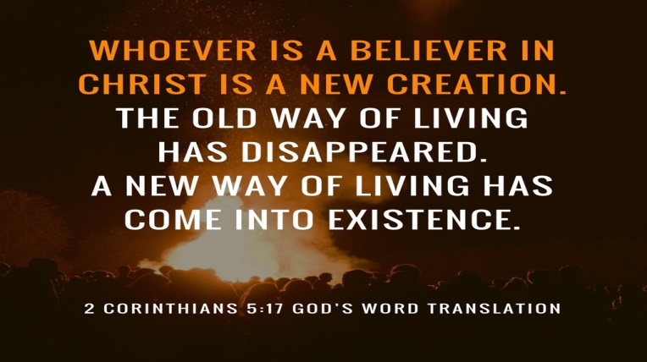

Introduction
The mustard seed becomes a great shrub that shelters the birds, recalling ancient images of the tree of life. We’d expect a cedar or a sequoia, but Jesus finds the power of God better imaged in a tiny, no-account seed. It’s not the way we expect divine activity to look. Yet the tree of life is here, in the cross around which we gather, the tree into which we are grafted through baptism, the true vine that nourishes us with its fruit in the cup we share. It may not appear all that impressive, but while nobody’s looking it grows with a power beyond our understanding.

Gathering Hymn #807 Come Thou Font of Every Blessing
Hymn of the Day #679 For the Fruit of All Creation
Sending Hymn #638 Blessed Assurance

Prayer of the Day
O God, you are the tree of life, offering shelter to all the world. Graft us into yourself and nurture our growth, that we may bear your truth and love to those in need, through Jesus Christ, our Savior and Lord. Amen.

First Reading: Ezekiel 17:22-24
Tree imagery is used in a messianic prophecy to tell how the Lord will choose someone from Judah’s royal family (the cedar tree) to reign over all creation. This tree will be planted on Mount Zion, the location of the holy temple.
²²Thus says the Lord God: I myself will take a sprig from the lofty top of a cedar;
I will set it out. I will break off a tender one from the topmost of its young twigs;
I myself will plant it on a high and lofty mountain.
²³On the mountain height of Israel I will plant it in order that it may produce boughs and bear fruit,
and become a noble cedar. Under it every kind of bird will live; in the shade of its branches will nest
winged creatures of every kind.
²⁴All the trees of the field shall know that I am the Lord. I bring low the high tree, I make high the low tree; I dry up the green tree and make the dry tree flourish. I the Lord have spoken; I will accomplish it.
L: Word of God. Word of life. C: Thanks be to God.
1

Psalm 92:1-4, 12-15
The righteous shall spread abroad like a cedar of Lebanon. (Ps. 92:12)
¹It is a good thing to give thanks to the Lord, to sing praise to your name, O Most High;
²to herald your love in the morning and your faithfulness at night;
³on the psaltery, and on the lyre, and to the melody of the harp.
⁴For you have made me glad by your acts, O Lord;
and I shout for joy because of the works of your hands.
¹²The righteous shall flourish like a palm tree, and shall spread abroad like a cedar of Lebanon.
¹³Those who are planted in the house of the Lord shall flourish in the courts of our God;
¹⁴they shall still bear fruit in old age; they shall be green and succulent;
¹⁵that they may show how upright the Lord is, my rock, in whom there is no injustice.

Second Reading: 2 Corinthians 5:6-17
Paul encourages believers to live by faith and not by sight. We do not consider Jesus from a human perspective but through the eyes of faith, believing he died for all and was raised. All who are in Christ are now in God’s new creation.
⁶So we are always confident; even though we know that while we are at home in the body we are away from the Lord—⁷for we walk by faith, not by sight. ⁸Yes, we do have confidence, and we would rather be away from the body and at home with the Lord. ⁹So whether we are at home or away, we make it our aim to please him. ¹⁰For all of us must appear before the judgment seat of Christ, so that each may receive recompense for what has been done in the body, whether good or evil.
¹¹Therefore, knowing the fear of the Lord, we try to persuade others; but we ourselves are well known to God, and I hope that we are also well known to your consciences. ¹²We are not commending ourselves to you again, but giving you an opportunity to boast about us, so that you may be able to answer those who boast in outward appearance and not in the heart. ¹³For if we are beside ourselves, it is for God; if we are in our right mind, it is for you. ¹⁴For the love of Christ urges us on, because we are convinced that one has died for all; therefore all have died. ¹⁵And he died for all, so that those who live might live no longer for themselves, but for him who died and was raised for them.
¹⁶From now on, therefore, we regard no one from a human point of view; even though we once knew Christ from a human point of view, we know him no longer in that way. ¹⁷So if anyone is in Christ, there is a new creation: everything old has passed away; see, everything has become new!

L: Word of God. Word of life. C: Thanks be to God.

Gospel: Mark 4:26-34 (Before Reading): Glory to you. O Lord.
Jesus frequently uses parables to teach ordinary people as they are able to hear and understand. Images of sowing and growing show the vitality of God’s kingdom.
²⁶[Jesus] said, “The kingdom of God is as if someone would scatter seed on the ground,²⁷and would sleep and rise night and day, and the seed would sprout and grow, he does not know how. ²⁸The earth produces of itself, first the stalk, then the head, then the full grain in the head. ²⁹But when the grain is ripe, at once he goes in with his sickle, because the harvest has come.”
³⁰He also said, “With what can we compare the kingdom of God, or what parable will we use for it? ³¹It is like a mustard seed, which, when sown upon the ground, is the smallest of all the seeds on earth; ³²yet when it is sown it grows up and becomes the greatest of all shrubs, and puts forth large branches, so that the birds of the air can make nests in its shade.”
³³With many such parables he spoke the word to them, as they were able to hear it; ³⁴he did not speak to them except in parables, but he explained everything in private to his disciples.
(After Reading): Praise to you, O Christ.

Prayers of Intercession
Let us come before the triune God in prayer. A brief silence.
Holy God, you plant the seeds of faith in every nation. Enliven your church, so that the good news of your grace may root and grow throughout the world. Lord, in your mercy, hear our prayer.
Creator, even the trees, shrubs, and flowers delight in your goodness. From the depths of the soil to the highest mountain, bring forth new plants. Restore growth to places suffering drought. Lord, in your mercy,
hear our prayer.
2
Judge of nations, we pray for our leaders and those in power. Grant them the ability to regard those under their charge with humility, dedicating their lives in service to others. Lord, in your mercy, hear our prayer.
Divine comforter, you show compassion to those in need and provide relief to those who call on you. Bless all who suffer, especially people trapped in cycles of poverty and homelessness. We pray for those on our Current prayer list: Bonnie Hileman, Becky Oden, Nancy Jamerson, Dean McKinley, Linda Rager Hampton, Lynn Ryan, the Rapley family. Those on our Ongoing prayer list: Jon Perkins, Peggy Gilbert, Mara Joy Nelson, Owen Vannoster and family. We pray for our Hombound: Marie Betten-Niccum, Joanne Boettcher, Nancy Coble, Betty Hamlin, Ruth Hauser, Betty Lawrenz, Robert & Lois Dowd. We pray for those requests from our Community Meal: Kathy, Marjorie, Mary, Jay, Bill, Jim R., Tom S., Ryan, Debbie, Cole, Kathy, Rick, Kimberly, Alison, Glenda, DeLauder family, Connie, Mata Reyes family, Lucy and Tim, Marty and Tom, Brandon, Kyle, Raymond and Tim, Gary, Ann and Pat, Van Haupert family, Kayla, Ruth Ann, and our country. Hear our prayer concerns, spoken silently or aloud as we lift them to you………… Lord, in your mercy,hear our prayer.
Sovereign God, this house of worship belongs to you. We give thanks and pray for our church musicians, Alan and Pam. We dedicate to you the joyful noise that comes from this place; the cries of children, the melody of voice and instruments, and the songs from our hearts. Lord, in your mercy, hear our prayer.
Eternal God, we give thanks for our ancestors in the faith who are now at home with you. We look forward to that day when we are reunited in your new creation. Lord, in your mercy, hear our prayer.
We lift our prayers to you, O God, trusting in your abiding grace. Amen.

Announcements:

Thanks to Teresa and Graham for serving as our Synod Assembly delegates this past week. It was a much different experience being virtual but God was there and the Spirit was moving.

Church Council will meet immediately after worship.

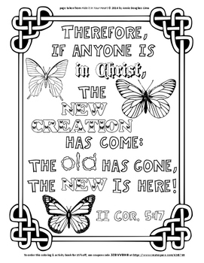
3

